For questions 1-3: Solve the system of equations by graphing. If need be check your answer.
1. y = $\frac{1}{2}$ x
y = −x + 3
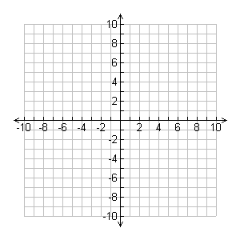
What is/are the solutions? One, none, infinitely many
2. y = 2x – 1
y = 2x + 3
What do you notice about these lines?

What are the solutions? One, none, infinitely many
3. y = $\frac{1}{3}$x – 1

3y = x – 3
What do you notice about these lines?

What are the solutions? One, none, infinitely many

4.) A line passes through points (0, -3) and (4, 1). (8EE8c)
Another line passes through points (1, -2) and (0, -1).
Determine whether the lines intersect. Explain why/why not.
If they do not intersect are they parallel or coincident? Explain.

5.) A line passes through points (0, 3) and (1,5)
Another line passes through points (1, 1) and (2, 3).
Determine whether the lines intersect. Explain why/why not.
If they do not intersect are they parallel or coincident? Explain.

Solving Systems by Inspection (8EE8b)
Does the following system of equations have one, none, or infinitely many solutions?
Tell what the lines would look like: parallel, intersecting, coincident.

1.) x + y = 1
x + y = 5 Solutions Lines

2.) x + y = 2
3x + 3y = 6 Solutions Lines

3.) y = 2x + 7
y = 3x + 4 Solutions Lines

4.) x + y = 4
y = ⁻ x ― 2 Solutions Lines

5.) x + 4y = 2
2x + 2y = 8 Solutions Lines

Solving Systems by SUBSTITUTION (8EE8b)
6.) Explain what it means when you arrive at a true statement when solving a system of equations using substitution.

Solve the following system of equations using substitution. Check your work.
7.) y = x – 1
2x – 3y = -1

8.) y = 5x
3x – 2y = 14

9.) ⁻3x + 3y = 4
⁻x + y = 3

Solve Systems by Elimination (8EE8b)
Solve the following system of equations using elimination. Check your work.
10.) 5x – 2y = 11
5x + 2y = 9

11.) 4x + 7y = 10
4x + 7y = ⁻1

12.) 6y + 3x = 6
⁻3y + 2x = 4

Real World Connections

13.) Clara bought two t-shirts and a hot dog at a baseball game and spent $31.75. Her friend bought three t-shirts and two hot dogs and spent $51. All of the t-shirts cost the same amount, as do the hot dogs. What is the price of each? Solve by writing a system of equations to represent the situation.

14.) Chelsea and Zack are both dog sitters. Chelsea charges $2 per day plus a sign-up fee of $3. Zack charges a flat rate of $3 per day. Write a system of linear equations to find out after how many days Chelsea and Zack earn the same amount for dog sitting. What is the amount?

